
EE490A/BIO490AL
Senior Project – Milestone Report 1
Report Information
Project Title | Adjustable Arm Prosthetic
Team Name | Basel Abumailish, James Briscoe, Eric Carlos
Course / Section | EE490A/BIO490AL
Instructor / Advisor | Peter Han/ Airs Lin
Milestone 1 | Part acquisition/ Create and Design Base models of the circuit/ telescoping rod/ fingers/ and AAP
Reporting Period (Start – End) | 1/5/26 - 1/19/26
Submission Date | 1/19/26
Team Members + Roles (Name – Role – Responsibilities) List all members | Basel Abumailish: Biomaterial/ 3D design  James Briscoe: 3D design/ Part production/ QA  Eric Carlos: Circuit Design/ Software/ Hardware

1. Executive Summary (½ page max)
Briefly describe:
The milestone was supposed to cover the basic creation and design process of the AAP as a whole, the base circuit design, and the base designs for the fingers and telescoping rod. The base designs for the above were created, and some small obstacles arose during the process. During the creation of the base AAP design, we realized that the location of the telescoping rods may get in the way of the actuator, which is going to pull the lines from the hands and the fingers to fully contract the fingers, allowing them to close around an object. The solution was to move the linear actuator between the rods to ensure there is no interference with its operation. During the base design for the fingers, the hole, which acts as the knuckle and creates a point of leverage allowing the finger to bend, was offset incorrectly, causing an issue with the finger joints aligning. This will be corrected by an offset of 5mm to ensure the fingers bend correctly. During the telescoping rod development, there were issues with getting the rod to successfully lock in place. This will be fixed with a pin system held throughout to ensure the rod does not collapse during extended use. During the initial circuit creation, there were some issues with the electrical components being used. The system was updated with the particular components we will be using for our circuit, and the issue was solved. Overall the first stages of research and development had some small hiccups but allowed us to improve the design for maximum efficiency. This caused a slight day delay but overall, the objectives for milestone 1 were met.

2. Milestone Objectives and Success Criteria
Planned Objectives (from project plan):
∙ Objective 1: Part acquisition
∙ Objective 2: Creation circuit base model
∙ Objective 3: Creation of AAP base model/ finger joints/ adjustable rod

Success Criteria/ Acceptance tests(measurable):
∙ Criterion 1: All parts were acquired
∙ Criterion 2: Base circuit model was created
∙ Criterion 3: Base AAP, fingers, adjustable rod, and self-lacing housing

3. Work Completed This Period
Completed Tasks
Task | Owner | Date Completed | Notes / Evidence
Base AAP model v1-v3 | James Briscoe | 1/10/26 | Design Below V3
Part Acquisition | Eric Carlos | 1/11/26
Base Adjustable rod | James Briscoe | 1/13/26 | Design Below V2
Base Finger Design V2 | Basel Abumailish | 1/15/26 | Design Below V2
Base lacing spool design V1 | James Briscoe | 1/16/26 | Design Below
Biomaterial study | Basel Abumailish | 1/16/26 | https://www.sciencedirect.com/science/article/abs/pii/S0169814107002090  https://www.sciencedirect.com/science/article/abs/pii/S1044532307000966
Circuit Design | Eric Carlos | 1/16/26 | Design Below(still improving)
Coding Design | Eric Carlos | In Progress

Deliverables Produced

AAP base model V3
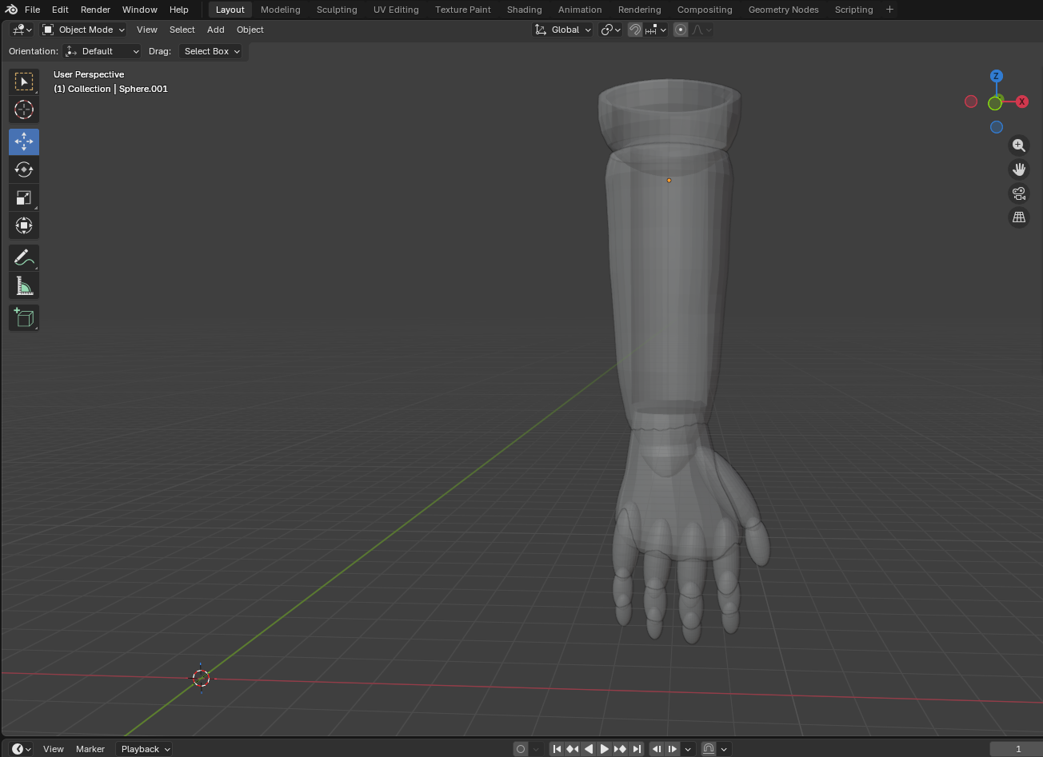
Extending rod base model V2
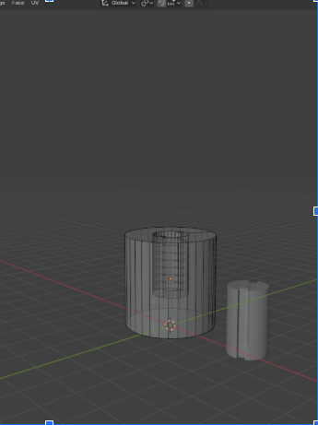

Finger design V2
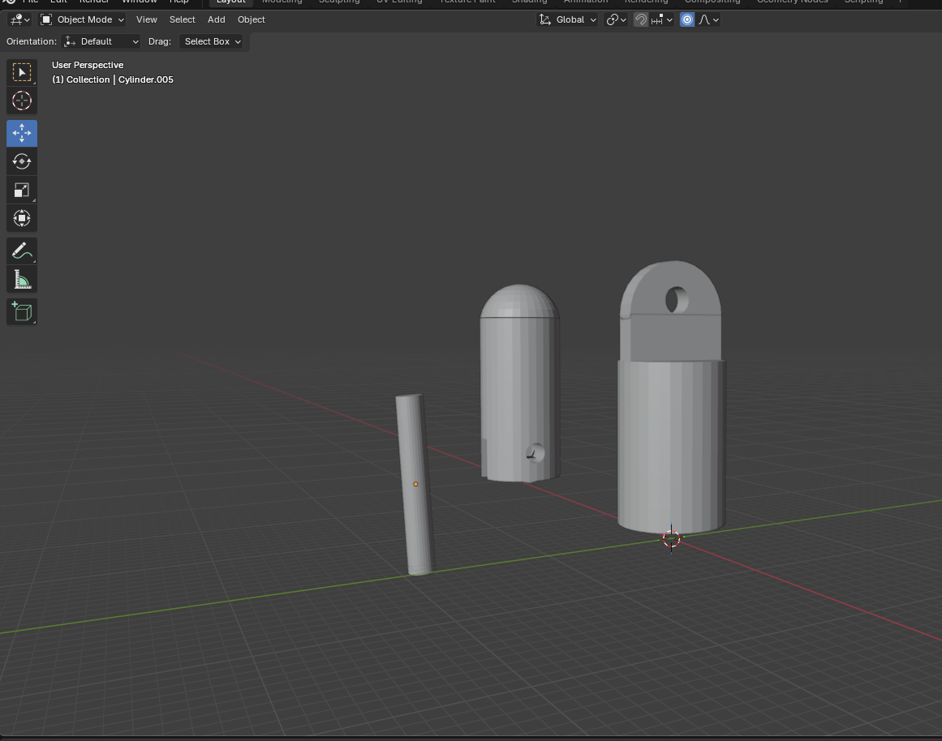
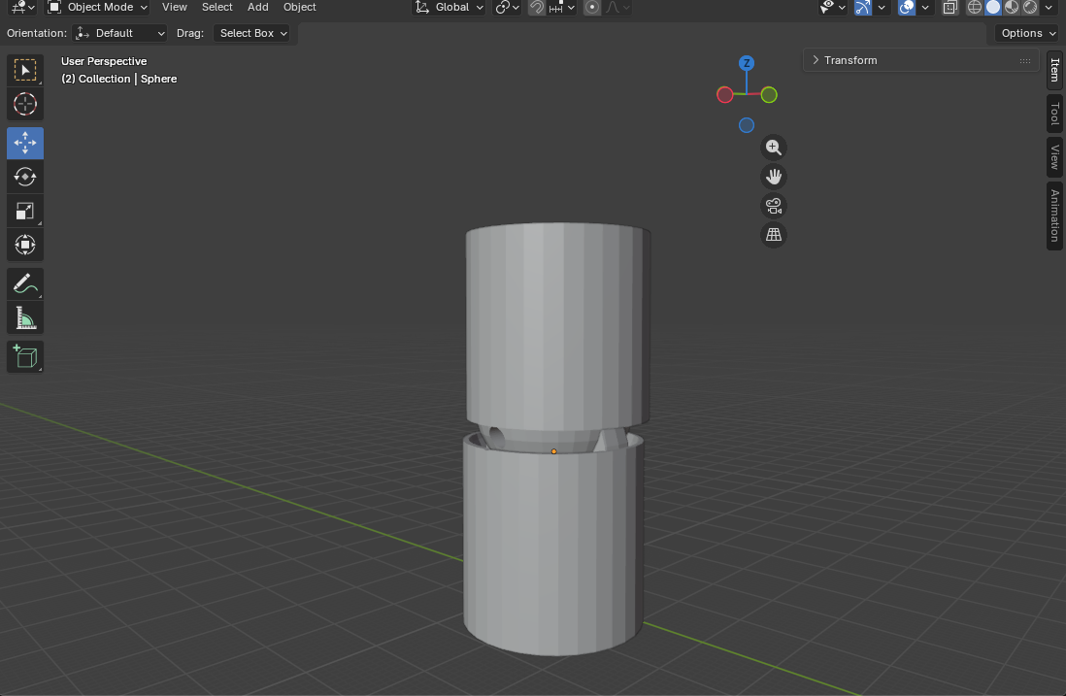

Self-lacing Spool and Cog
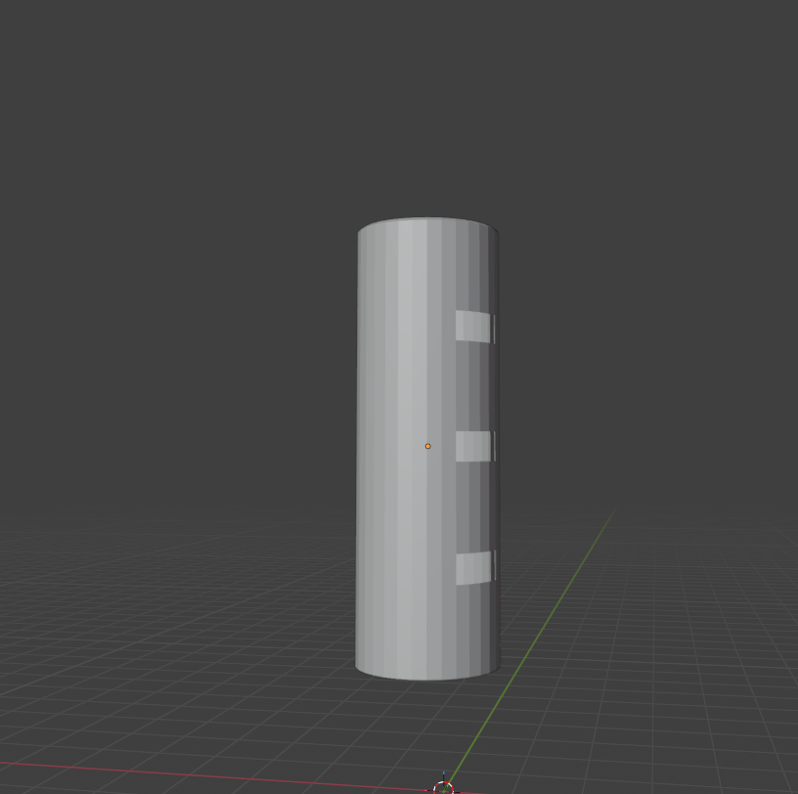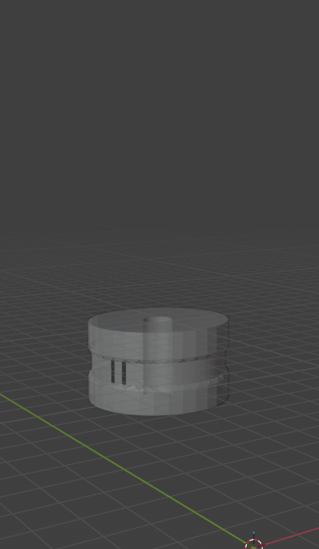

Base Circuit Design(Need to add more)
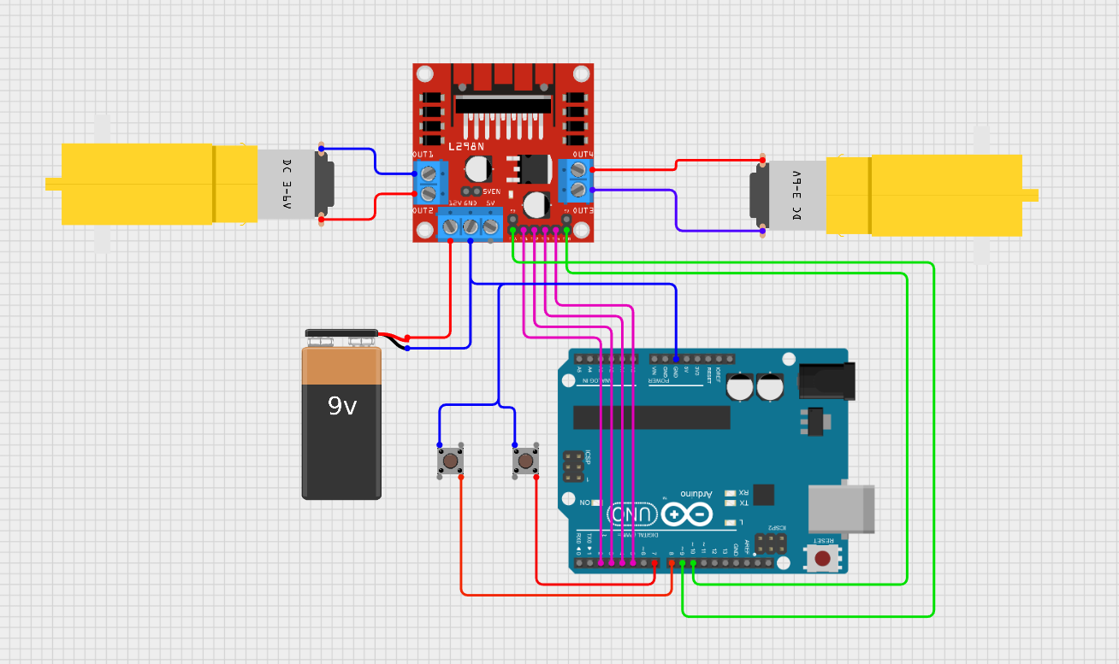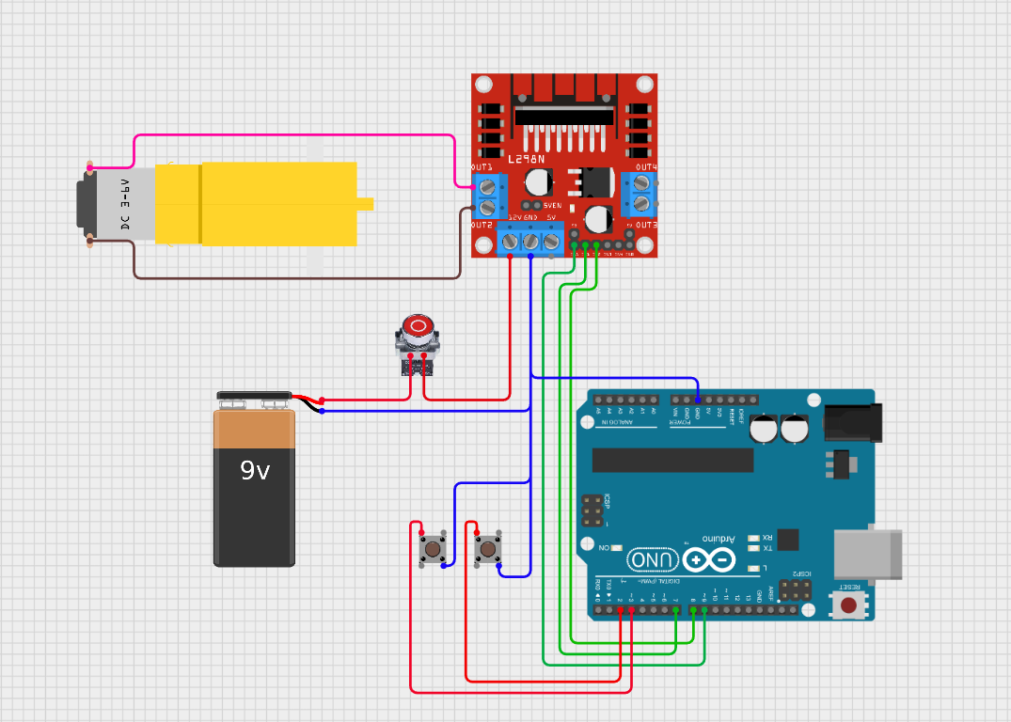
Base Coding Design
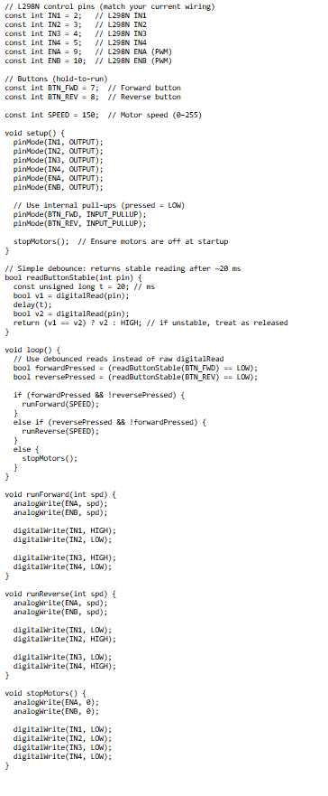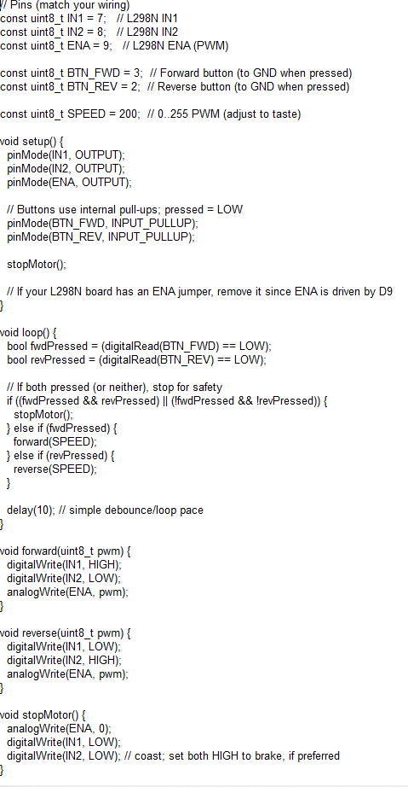

4. Technical Progress (EE and Biomedical -Focused)
4.1 Requirements and System Design Updates
During the first two weeks, there were some small adjustments to the design to ensure proper function. The initial finger design, as shown above, is able to bend, but not at the rate we expected. The upper and lower parts being flat does not allow for any movement past 10 degrees. This will be addressed with version 3 of the finger design by creating ball joints to allow 90 degrees of motion on the joints. The adjustable rod that allows the prosthetic to grow was having issues locking into the grooves that were created. Version 3 will have locking pins allowing the rod to lock into different positions so that the user can adjust the size accordingly without sacrificing the integrity of the rod. With the fingers the cable runs were originally going to be exposed at the joints of the fingers. If the lines get cut or caught it will make the fingers useless. To mitigate the issue the cable runs will be internal so they have smaller risk of being cut or caught. With the circuit there were some issues with the power supply providing enough power, so we switched power supplies before we ordered the power supply we are utilizing.

4.2 Hardware Design Progress
May need separate motors with low voltage sources
Instead of using dual motor controller i may need to use chips
Breadboard may be needed to separate voltage sources
Trying to figure out how to stop backfeed of voltage may use capacitor
Add sensor or thermal button as E-stop
Dual Motor controller Driver

4.3 Firmware / Software Progress
Base Code / Needs improvement to add to motors or may need two separate codes
Circuit design base / need to add correct components and improve design

4.4 Integration Progress
Cirkit Designer IDE program test with code
Breadboard test when diagram complete

5. Test and Validation Results
Tested Base circuit on Cirkit Designer with code (link at end provided has testable circuits)
Test Name | Setup /  Procedure | Expected  Result | Actual Result | Pass/Fail | Evidence
Digital circuit | Cirkit designer IDE | To run both motors w/ general code | Good, just need to improve | Pass | https://app.cirkitdesigner.com/project/5c0979d5-f713-457d-92e9-6de71a40811d
Digital circuit | Cirkit Designer IDE | One motor self lacing w/ emergency stop | Not too sure if the E-stop will work or not | Fail | https://app.cirkitdesigner.com/project/1fe1960a-15b2-40e8-987d-4e9e13111ca5
Workout band | Research | To give a better grip on the end of the prosthetic cup | Fails as prolonged contact with latex on the skin leads to an allergy and reaction | Fail | https://www.sciencedirect.com/science/article/abs/pii/S0169814107002090
3D Test Prints | 3D Printing | Solid 3D prints with no holes or voids in the models | Printed miniature models to verify the integrity of the 3D model | Pass | Pictures below
Finger Joint Test | Physical limit test | Verify joint is able to move and bend 90 degrees | Wasn't able to bend past 10 degrees | Fail | Pictures below
Extending Rod test | Physical limit test | Verify rod is able to extend and lock into position | Rod was able to slide but not lock into position. Pins will be used in V3 to lock. | Fail | Pictures below

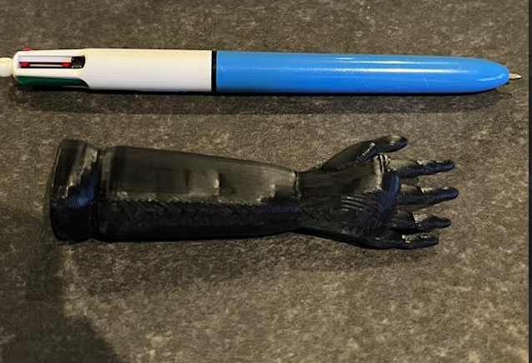
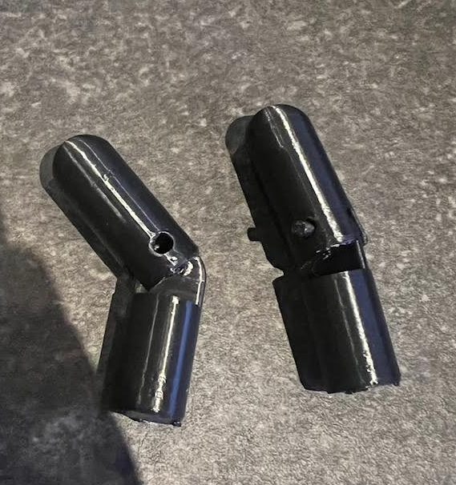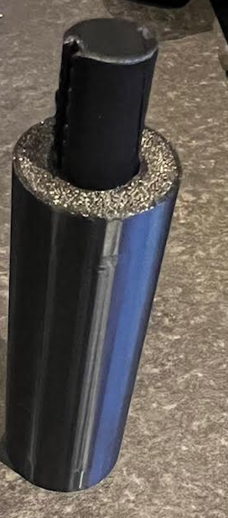

6. Issues, Risks, and Mitigations
Issues Encountered (this milestone)
Issue | Impact | Owner | Status | Resolution / Next Steps
Latex on skin | Prolonged contact with latex leads to skin rashes and allergy complications | Basel Abumailish | Ongoing | Need to find a suitable alternative, such as silicon, to avoid allergic complications of latex on the skin
Code | Using base code and trying to add on E-stop and second motor | Eric Carlos | Ongoing | Need to figure out if I need two separate motors controlled by different sources
Circuit | Design | Eric Carlos | Ongoing | 2 Circuits diagram I am working on to see if the initial idea would work
The finger joint is not bending naturally | The finger joint connects and is able to place a pin to secure, but it will not bend like a finger | Basel Abumailish | Ongoing | Will look into editing the model so that the joining can bend in a natural motion
Extending Rod not locking | The inner rod slides in the tube fine but doesn't stop at the limit. | James Briscoe | Ongoing | Will adjust design and use pins to lock in place.
Cable runs for fingers | The cables need to be within the prosthetic to ensure they don't get cut or caught | James Briscoe | Ongoing | Will create runs in the fingers to minimize exposed cabling on the fingers

Project Risks (ongoing)
Risk | Likelihood  (L/M/H) | Severity (L/M/H) | Mitigation Plan | Trigger / Watch Item
Stability of extending rod | Low | Med | Create a simpler extending rod | Test all 3D prints of extending rod
Thickness of 3D prints | Low | High | Edit thickness of all prints to ensure thickness will support weight | Test all prints as miniatures before doing full scale prints.
Creating

7. Schedule and Milestone Status
Milestone Status: ☐ On Track ☐ At Risk ☐ Behind
Planned vs Actual
Item | Planned Date | Actual Date | Variance | Notes
Base AAP model v1-v3 | 1/19/26 | 1/10/26 | Version 3
Part Acquisition | 1/19/26 | 1/11/26
Base Adjustable rod | 1/19/26 | 1/13/26 | Version 2
Base Finger Design V2 | 1/19/26 | 1/15/26 | Version 2
Base lacing spool design V1 | 1/19/26 | 1/16/26 | Version 2
Biomaterial study | 1/19/26 | 1/16/26
Circuit Design | 1/19/26 | 1/16/26 | Version 2
Coding Design | 2/2/26 | In Progress

Gantt / Timeline Update (brief)
∙ Timeline is still on track. All objectives for the base models and designs have been completed. The next two weeks will be for fine tuning and verifying design is operating how we intend.

8. Budget / Parts Tracking (if required)

Item | Qty | Unit Cost | Total | Vendor | Ordered? | ETA | Notes
Loop Band Kit Latex Resistance Bands | 1 | $13.00 | $14.01 | Target | Bought in person | N/A

Total Spent to Date:
Budget Remaining:

9. Team Contribution Summary

Member | Contributions This Milestone | Hours (est.)
James Briscoe | AAP base model, Adjustable rod base model, self lacing spool base model, printing and testing model structures | 25 Hours
Basel Abumailish | Finger joint design and biomaterials research | 25 Hours
Eric Carlos |  | 25 Hours

10. Next Steps (Next Milestone Plan)
Top Priorities for Next Period
1. Improve the finger joints' design so that they bend naturally
2. Verify placement of all items in the forearm and have a bigger scale model
3. Verify Coding
Planned Tests / Demos
∙ Test: Testing limits of fingers and ensuring prints are durable enough
∙ Demo: Verifying finger test and verifying locations of electronics within the arm
Dependencies / Help Needed
∙ Help needed from Mr. Lin with some coding questions
11. Appendix

Include any supporting items such as:
Team Lead Rotation
Current Team Lead: James Briscoe
Basel Abumailish: 1/19/26 - 2/2/26
Eric Carlos: 2/2/26- 2/16/26
James Briscoe: 2/16/26- 2/23/26
Basel Abumailish: 2/23/26 - 3/2/26
Eric Carlos: 3/2/26- 3/9/26
James Briscoe: 3/9/26- 3/16/26

